**26. Query to display Name and Employee no. Along with their supervisor’s Name and the supervisor’s employee no; along with the Employees’ Name who do not have a supervisor.**

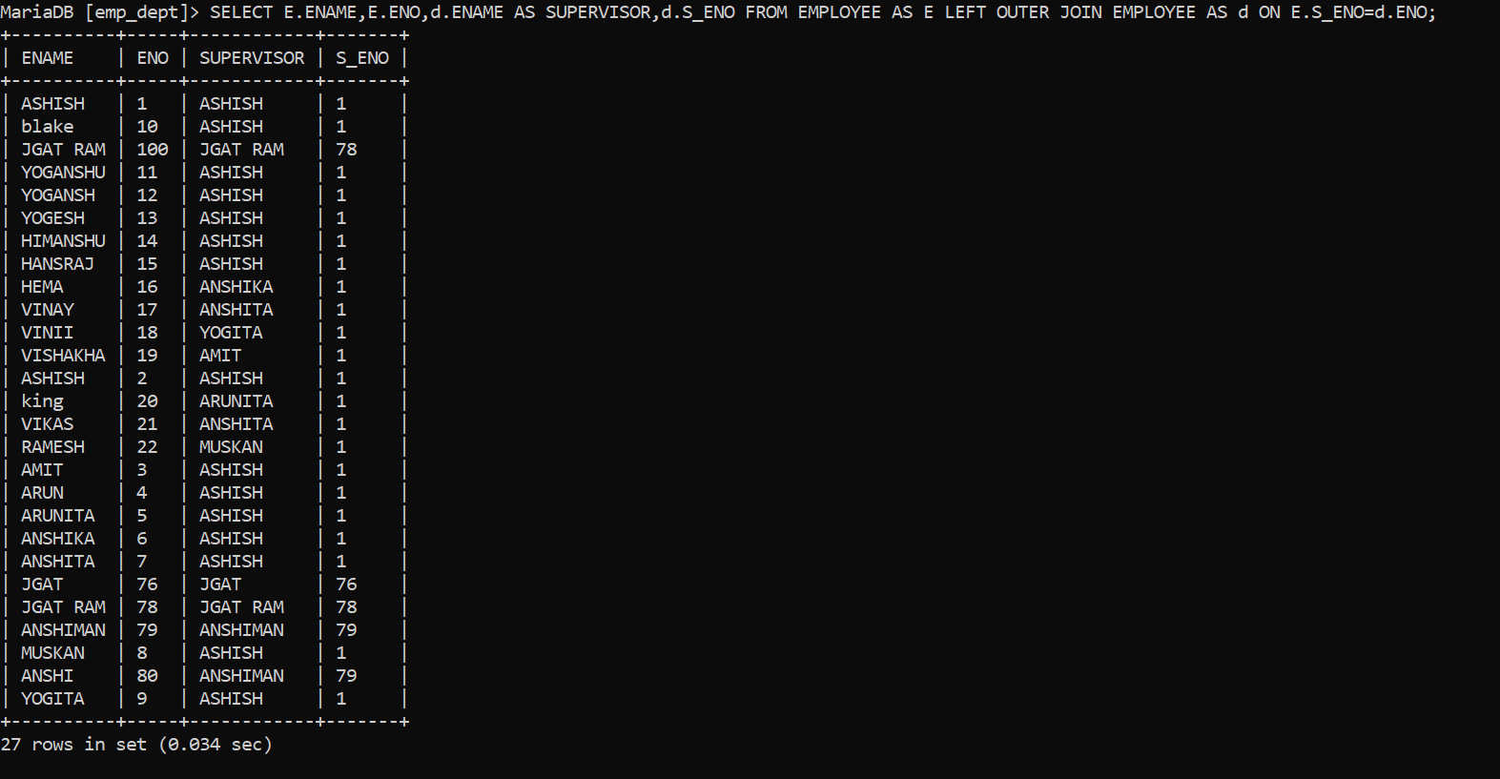

**27. Query to display Name, Dept No. And Salary of any employee whose department No. and salary matches both the department no. And the salary of any employee who earns a commission.**

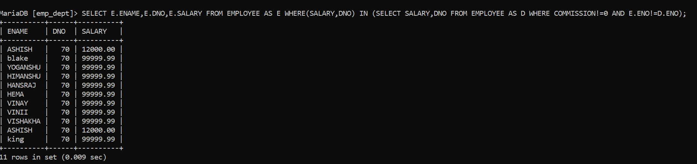

**28. Query to display Name and Salaries represented by asterisks, where each asterisk (*) signifies $100.**

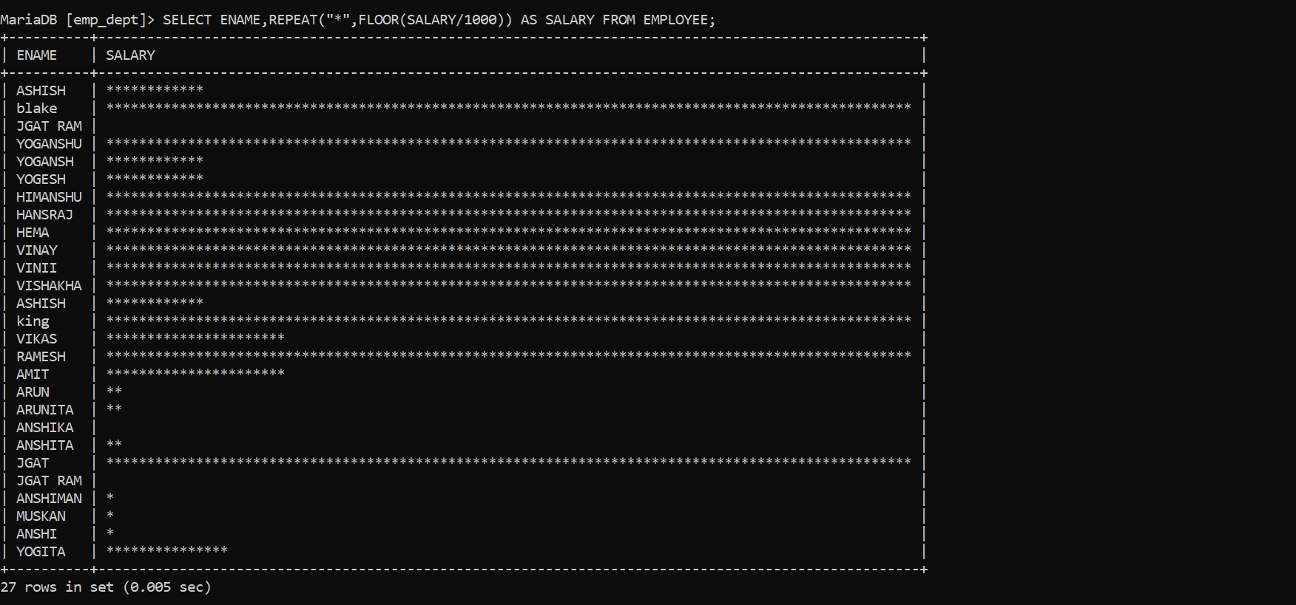

**29. Query to display the Highest, Lowest, Sum and Average Salaries of all the employees**

